Prayer Letter Pastor Nasir’ family and Ministry Pakistan September-2026
"Therefore, encourage one another and build one another up, just as you are doing." 1 Thessalonians 5:11
Dear Brothers and Sisters Greeting from Pakistan:

Family News
We are thankful to the Lord for His faithfulness and grace over our family. Joshua, Jerome, and Jonathan are all busy with their studies and working hard in their schoolwork. Joshua will be appearing for three important examinations during September and October, and we would greatly appreciate your prayers for him. Please pray that God will give him wisdom, understanding, good health, strength, and peace as he prepares for and takes his exams. We also kindly ask you to pray for Sabahat, who has been experiencing pain from arthritis. Please pray for complete healing, renewed strength, and relief from pain, and that the Lord will continue to sustain and encourage her each day. We are trusting God for His provision, protection, and blessing upon our whole family. We went to the doctor he suggested us to for her blood tests, we will get reports in a couple of days, need constant prayers. Please pray for our family support to be increase.
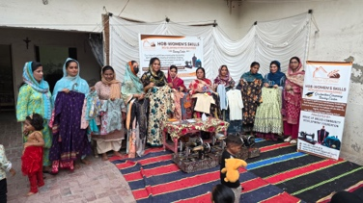
House of Bread-Women skills Development Program
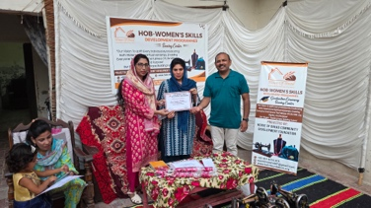
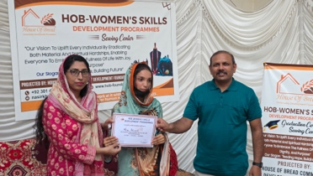
The House of Bread Sewing Center recently celebrated the graduation of nine young women who successfully completed a six-month sewing and skills-training course. Among the graduates were eight Christian girls and one Muslim girl, creating a beautiful example of learning, fellowship, and mutual respect. From the very beginning of the course, each class started with prayer and a time of Bible devotion. These moments helped the students not only develop their sewing skills but also grow spiritually and reflect on how their faith can influence their everyday lives. During the six months, the students learned practical sewing skills that can help them become more confident and provide opportunities for income generation in the future. At the graduation ceremony, the students celebrated the completion of their training with gratitude and joy. All the graduates made a commitment to continue beginning their daily lives with prayer and devotion, carrying forward what they had learned during their time at the House of Bread Sewing Center. We are thankful to God for the opportunity to invest in these nine young women. We pray that the skills, values, and spiritual foundation they received will continue to guide them and positively impact their families and communities. Karachi center is also performing well.
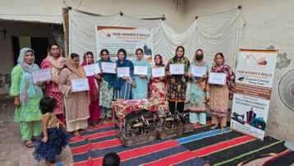
Rida has successfully completed her sewing course at the House of Bread. She is very grateful for the opportunity to learn a valuable skill that can help her become more confident and independent. Rida appreciates the House of Bread for providing this training and giving her the opportunity to learn and prepare for a better future. She is thankful for everyone who has supported this program and hopes to use her new skills to bless her family and community.
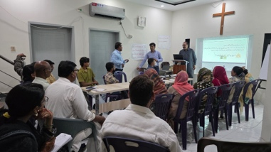
House of Bread- Leadership Development Program "Beyond Success"
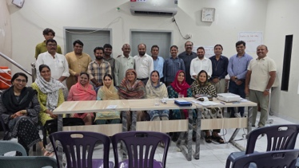
We are thankful to God for the opportunity to conduct the John C Maxwell “Beyond Success” leadership training, where 21 church leaders gathered at our worship place upstairs in our home. The training was a refreshing and encouraging time for everyone. The leaders learned new and practical approaches to leadership, helping them understand how to lead not only their churches but also their families and communities with greater wisdom, humility, and love. We praise God for refreshing each leader and pray that what they have learned will bring positive change and stronger leadership in their families, churches, and communities.
House of Bread Marwari Mission
It is always encouraging and a great blessing to see local Marwari communities worshipping the Lord in their own languages. Through the House of Bread Marwari Mission, we are reaching these communities with the Word of God while also serving their practical needs through education and community development projects. We praise God for the opportunity to see lives transformed spiritually, socially, and economically, and we pray that many more Marwari families will come to know the love and hope of Jesus Christ.
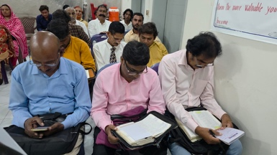
House of Bread Family Seminar
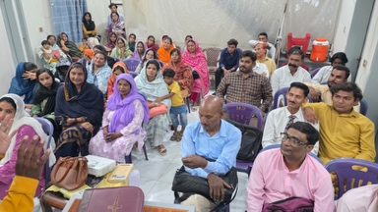
As Christians living in a Muslim-majority country, we face various challenges and pressures in our daily lives. During these difficult and sensitive times, it is important for the Christian community to remain strong in faith, stand firm in Christ, and continue to live as a witness with wisdom, love, and courage. We have received reports and concerns about some individuals or groups allegedly encouraging young Muslim men and women to develop friendships with Christian boys and girls with the intention of influencing them to convert to Islam. There are also concerns that some Christians who refuse such approaches or choose to remain firm in their faith may face intimidation, pressure, threats, or even false accusations of blasphemy. Such situations create fear and insecurity among Christian families and communities. We praise God for the opportunity to conduct a Christian Family Life Seminar, which was attended by 47 participants. The seminar focused on strengthening Christian families, encouraging healthy relationships, and helping believers understand the biblical principles for building Christ-centered homes. Both sessions were led by Pastor Jonathan White from the USA, who shared valuable biblical teaching and practical guidance for family life. The participants were greatly encouraged and blessed through the sessions, and we pray that what they learned will help them grow stronger in their faith and family relationships and become a blessing to others.
House of Bread Center for Digital Skills
We are thankful to God for the wonderful progress at the House of Bread Center for Digital Skills. We are glad on completion of a three-month Basic Computer Skills course by 13 Christian young people. It was a wonderful time of learning, growth, and encouragement as these young people gained practical computer skills that can help them in their education, future employment, and ministry. We are now looking for a qualified teacher who can lead the next level of training, focusing on online business and digital entrepreneurship. At the same time, we plan to begin a new group for Basic Computer Skills in the first week of September. This means that we will have two groups running simultaneously—one group receiving basic computer training and another group developing skills for online business. We are grateful for this opportunity to equip young people with valuable skills and pray that God will use this center to open new doors of opportunity and hope for their future. Our 1st group take test some 3 students got 90+ marks; everyone did a great job. We need your Prayer to work according to our plans.
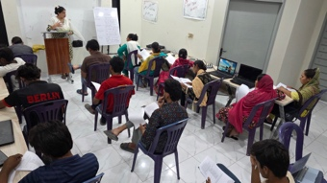
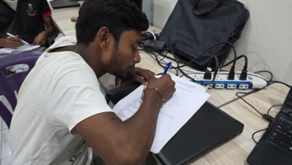
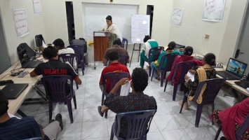
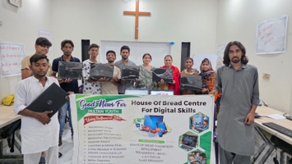
Aliza is a schoolteacher; she is grateful for providing her and other youngsters for digital skills. She is thankful to House of Bread initiatives for youth skills development.
House of Bread Education Project
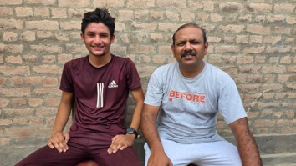
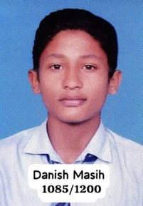
We are thankful to God for the wonderful achievement of Danish Masih, who has obtained very good marks in his Matriculation examinations. Danish comes from a very poor and struggling family, and his journey has not been easy. Danish’s biological mother, his first mother, sadly passed away after battling cancer. After her death, his father remarried, but Danish has continued to face many challenges and difficulties within his family and financial circumstances. Despite these hardships, Danish remained determined to continue his education and worked hard in his studies. We praise God for giving Danish strength, wisdom, and perseverance. His excellent Matriculation results are a great encouragement to us and demonstrate what can happen when a young person is given hope, support, and an opportunity to learn. We are grateful to all those who support the House of Bread Community Development Foundation and help children and young people from poor and marginalized families continue their education. Your prayers and support are helping create opportunities for young people like Danish to build a better future. Please continue to pray for Danish as he considers his next step in education. Pray that God will guide him, provide for his educational needs, and use his life as a testimony of His faithfulness and grace.
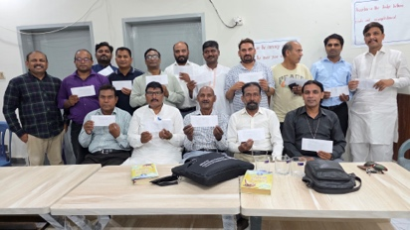
House of Bread Pastoral Care Program
We are thankful to God for the opportunity to support 16 pastors each month with a small love gift to help them continue serving in their ministries. These pastors are faithfully working in marginalized and underserved communities, often with very limited resources. Our monthly support is a small way of encouraging them, strengthening their ministry, and reminding them that they are not alone as they serve God and His people.

Praise Points
- Praise God for His protections during august-2026. We Appreciate your Prayers.
- Praise God for Sewing center graduation.
- Praise God for Marwari Communities.
- Praise God for Successful seminar on Christian Family life.
- Praise God for 13 students who learnt basic computer skills.
- Praise God for Successful Leadership Training.
- Praise God for House of Bread pastoral care program which is helpful for 15 pastors to reach the unreached with our support granted on a monthly level.
Prayer Points:
- Please Pray for Joshua Exams, Pray for Sabahat healing.
- Please Pray for me and Sabahat we have plan to visit Discipleship trainees in September to do follow up and two more training on discipleship.
- Please pray we will be released on more slaves of brick kiln. Helping on previous released man to get Moter bike Rikshaw to start small business. We will install to hand pumps for Marwari and Christian Poor Communities and starting small other projects for the development and Spiritual growth.
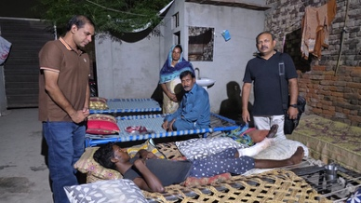
- Please pray for young Christians Boys and girls to be committed with their faith.
- Pray for Ejaz his leg is broken from 3 places by the road accident. Pray for his surgery process and complete healing.
- Now a days we are facing heavy power cut. Our services and classes are affected by this problem. We need Batteries to install to get power to be able to do Computer classes and Bible teachings without any interruptions. Please pray that the Lord Provide.
- Please pray for sister Riffat she has kidneys pains.
- Please pray for our Ministry Registration’s Process. It is taking too long. Pray that we could get License soon.
- There are flood predictions in Pakistan again this year, many areas are flooded already. please pray for protection.

Presented By:
Nasir and Sabahat
House of Bread Community Development Foundation.

