Newsletter Pastor Nasir’s Family and Ministry- July-2026
We ought therefore to show hospitality to such people so that we may work together for the truth." 3-John-1:8
Greetings from Pakistan:
Dear Brother Chris and AMEN Family:
We are Grateful for your constant Prayers and support.
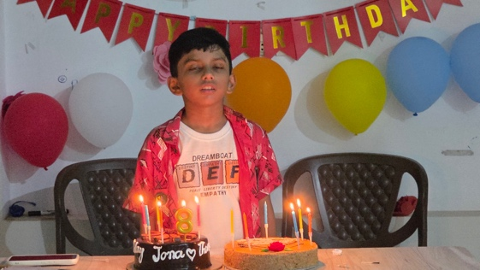
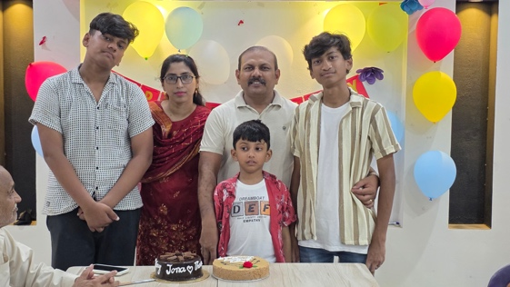
Family News: We give thanks to God for the wonderful celebration of Jonathan's 8th birthday. It was a joyful occasion filled with love, laughter, and fellowship among family and friends. We thank God for blessing Jonathan with another year of life, good health, wisdom, and growth. Please pray that He continues to protect, guide, and bless him as he grows in faith and knowledge. All 3 boys have been attending coaching classes but in July they are free from school for summer vacation. 3 of them are taking Music classes on weekly basis and Joshua and Jerome are attending sports academy as well. One thing is to mention, I need Wisdom to love them unconditional and make them successful.
Ministry News:
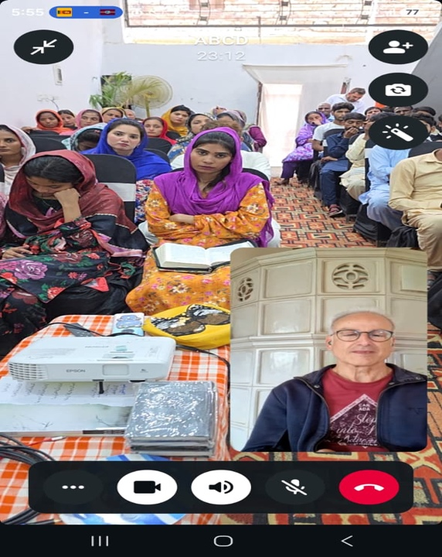
1-Family Seminar
A successful seminar on Family Life was conducted with an encouraging attendance and active participation from all those present. The session was both inspiring and practical, providing valuable insights into building strong, loving, and God-centered families. Brother Edwin delivered an impactful and engaging teaching. His message was enriched with personal experiences and real-life family examples, which made the lessons relatable and meaningful. The seminar concluded on a positive note, with attendees expressing appreciation for the practical wisdom and encouragement they received. It was a fruitful event that left participants motivated to strengthen their family lives and apply the lessons learned.
One Person Commented: He has been lazy in fulfilling my family responsibilities but today I confess before the Lord, I will do it from today, word of God has touched my heart.
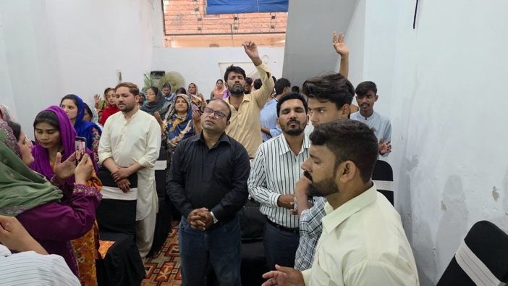
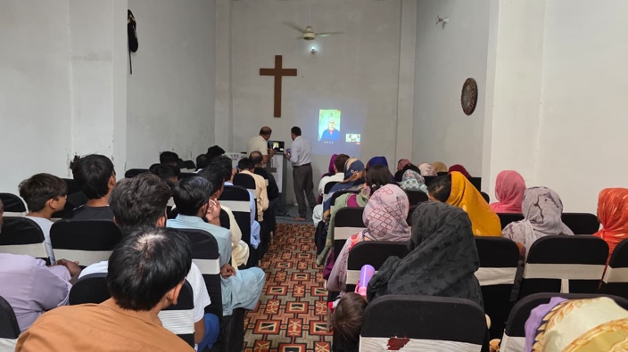
Pastor Sunny said: Bible teaching was very powerful, and I am thankful for Pastor Edwin’s teaching. These of seminar are very important to for our Christian Community in Pakistan.

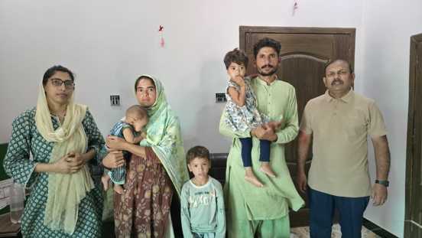
2-Two More Families Released from Brick Kiln Slavery
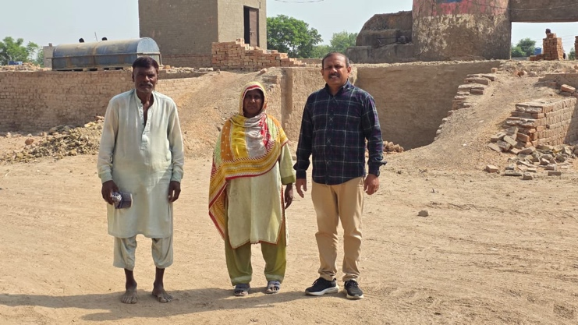
We are grateful to God to share the joyful news that two more individuals have been released from the bondage of brick kiln slavery. Mr. Dita had endured more than 25 years of labor in a brick kiln, while Mr. Shahzad had spent over 15 years trapped in the same system. After many years of hardship, they are now free to begin a new chapter in their lives with hope and dignity. Their release is a powerful reminder that lives can be transformed through compassion, prayer, and faithful support. We thank for friends who has stood with us in this mission to bring freedom and hope to those living in bondage. Please continue to pray for Mr. Dita and Mr. Shahzad as they rebuild their lives. Mr. Shahzad has 4 small children, Pray that God will provide them with good employment, strength, wisdom, peace, and opportunities to support their families. May they experience lasting freedom, restoration, and a future filled with hope.
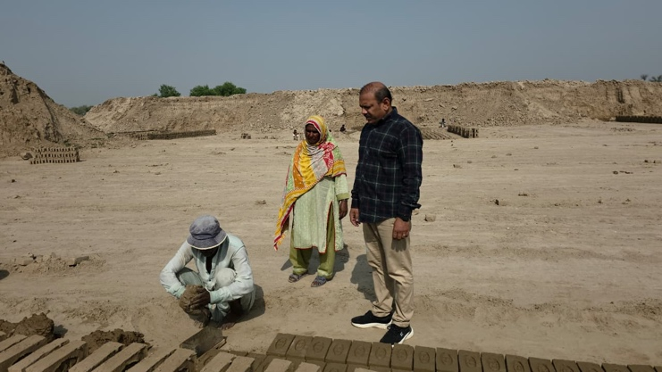

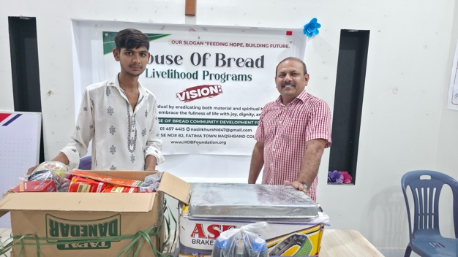
3- Small business (Livelihood)
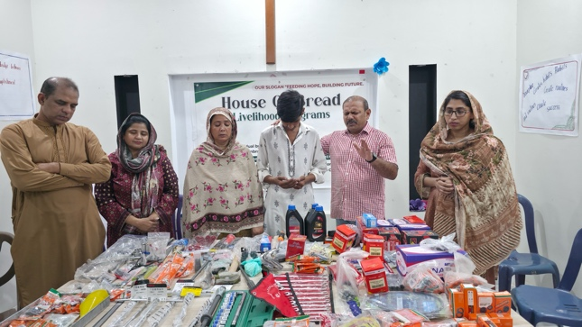
As part of our commitment to supporting vulnerable families, we had the privilege of assisting the son of a widow (recovering from surgery) by providing him with motor machine tools and other essential equipment to help him start his own small business. This support is intended to give him the opportunity to earn a sustainable income, become self-reliant, and provide for his poor family with dignity. We humbly pray that the Lord blesses this new venture, grants him wisdom, strength, and success in his work, and enables him to use these resources effectively. May this business flourish, bringing stability and hope to his family, and may God continue to provide for all their needs.

4-Medical Camp

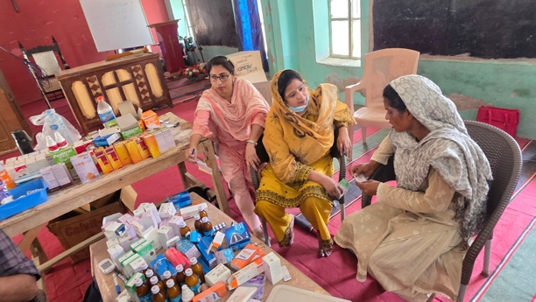
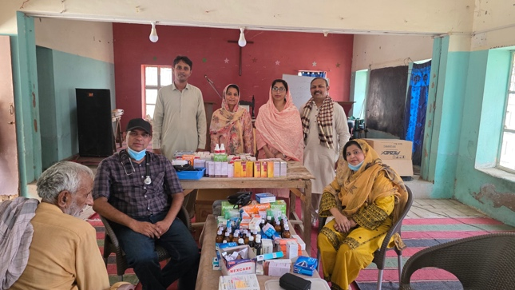
We thank God for His wonderful provision in making it possible to organize a medical camp for the poor and vulnerable people in our Christian village. Despite the extreme heat, with temperatures reaching 48°C, many people were suffering from illness and dehydration. This medical camp came at the right time and was a great blessing to the community. Many villagers attended the camp and received proper medical check-ups, free medicines, and professional healthcare advice. Everyone was grateful for the opportunity to receive quality medical assistance without any cost. The doctors and volunteers served with compassion and dedication, bringing hope and relief to those in need. The joy and gratitude on the faces of the people reflected God's love and care through this ministry. We sincerely thank everyone who prayed, supported, and contributed to making this medical camp a success. May God continue to bless all those involved and provide opportunities to serve more needy communities in the future. Also distributed Mosquito nets among widows.
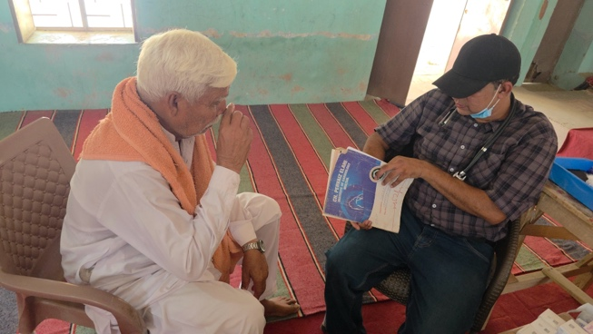
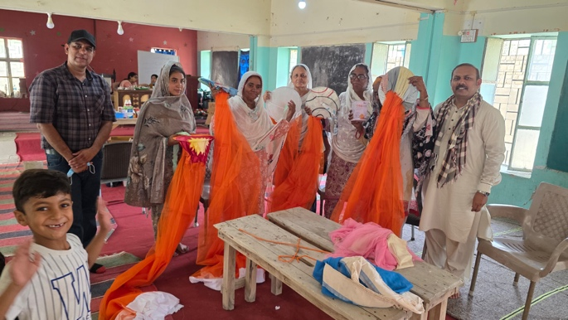
5-Persecution
Christians in Pakistan have faced persecution and discrimination for many years. Since the late 1990s, many Christian communities and human rights organizations have reported increasing concerns over religious intolerance, misuse of blasphemy laws, forced conversions, attacks on places of worship, and violence against religious minorities. These challenges have created an atmosphere of fear and insecurity for many Christians, affecting their ability to live, worship, and participate in society with equal rights and dignity. Pakistani Christian people have been always fighting for their rights but no solution yet. Please keep praying for the church in Pakistan.
6- House of Bread center for digital Skills.
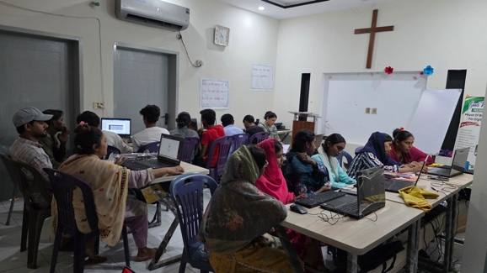
We are grateful to God for His faithful provision and guidance as we have successfully started the House of Bread Center for Digital Skills. We praise Him for making this vision a reality and for opening this new opportunity to serve our community. By God's grace, 16 students have enrolled in the first session. We believe this initiative meets an important need in our community, as many Christian young people have fallen behind due to a lack of access to practical digital skills and training. Our desire is to equip them with valuable skills that will help them build a better future and become confident, productive members of society. Please Pray that each student will learn diligently and grow in knowledge, confidence, and character. Pray for God's wisdom, strength, for the teachers and staff. Pray that this center will become a blessing to many more young people and bring glory to God.

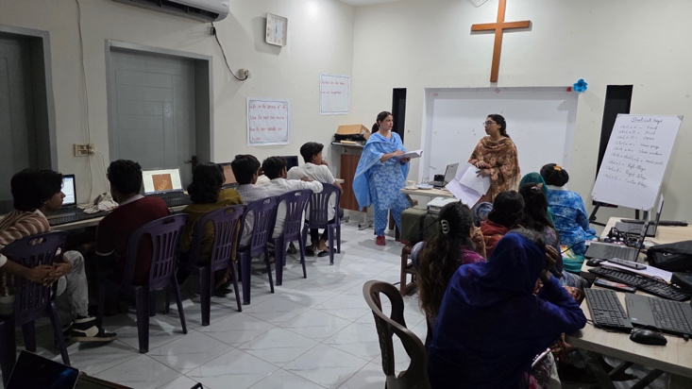
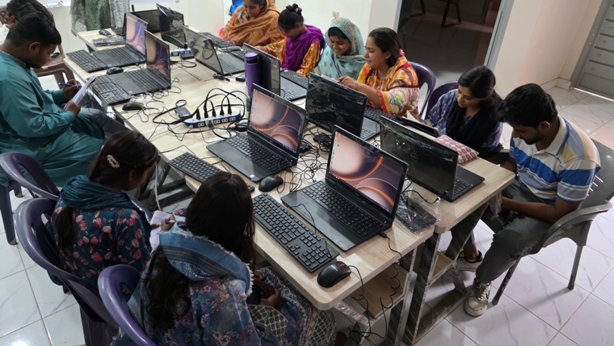
Praise and Prayer Points:
- We Praise God for His love and protection for my family, Thanks Lord for Jonathan’s birthday he turned to 8. Pray for my family.
- We Praise God for His provision for Bricks kiln slaves’ redemption.
- We praise God for provision for medical camp we served 138 people. Most the people were sick because of warm weather; we are facing 48+ temperature just like a burning body.
- We praise God for His provision for widow Razia’s son for livelihood. Young boys are very happy to start his own business.
- We Praise God for sewing centers, Literacy schools and Education project for poor children.
- We praise God for Marwari communities who are committed to worship the lord, in desert areas weather is to warn.
- We praise God for the provision of widows help on monthly basis.
Prayer Points
- Please pray for our running projects such as, sewing center, literacy schools and education projects and church Planting. Please pray for provision for new projects for to develop Christian Community in Pakistan.
- Please for the further process of
- Please pray for our trip to Karachi and Lahore for discipleship trainings and graduation ceremony of Sewing center and Literacy school at Karachi.
- Please pray for the provision of brick kiln rescued people to start up small businesses.
- We have plan to start some businesses for sustainably please pray for the doors opening. According to the research and having meeting with other friends we are suggested to have animal/goat farm, chicken farm and corn farms, where our people who has been released from the Slavery can work and get benefits.
- Please pray for our Center for digital skills. That students learn and grow.
- Please pray for persecuted brothers and sisters in Pakistan.
- Please pray for the wisdom for me, Sabahat and team to run all the projects effectively for His kingdom establish in Pakistan.
- Please pray for Sabahat health she has been suffering with arthritic pain.
- Please pray for the provision of instruments for online Gospel presentation.
- In my previous letter I mention for our organization registration Process. We got approved name “House of Bread Community development foundation” Please pray for the further documents which are yet to come.
- We are facing 6 to 8 hours power cut with 48+ temperature please pray for our health. We need an air conditioner for our Ministry office. Please pray.
- Please pray for Pastor Hazari leading Church fellowship at Marwari communities. Please pray for his quick recovery.
- War is ended but inflation is still a big challenge for our Country, please Pray for His mercy upon our nation.
- Now we need a proper place to Run our Projects and practice Sunday service. Please pray that Lord provides a piece of Land and resources to build up a Developments Center, to develop people physically, economically and spiritually according to our vision.
Our Vision is “To uplift every individual by eradicating both material and spiritual hardships, enabling everyone to embrace the fullness of life with joy and dignity.
Please keep praying and standing with us.
Presented by:
Pastor Nasir and Sabahat

