CASA VIETII SIGHISOARA
4TH MAY 2026 NEWSLETTER
Please take few minutes to read about the things what God is doing in this part of the world.
In the last months we been busy at Casa Vieti sharing the goodness of God thru material aid for mothers and their babies, having open our center for our medical aid and spiritual aid.
Last month in April we been able to share the love of God together with Lidia making 25 food parcels for 25 poor families right before Easter Sunday celebration.

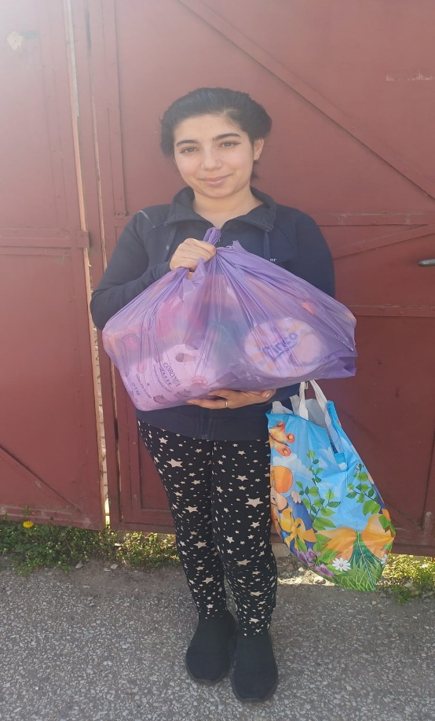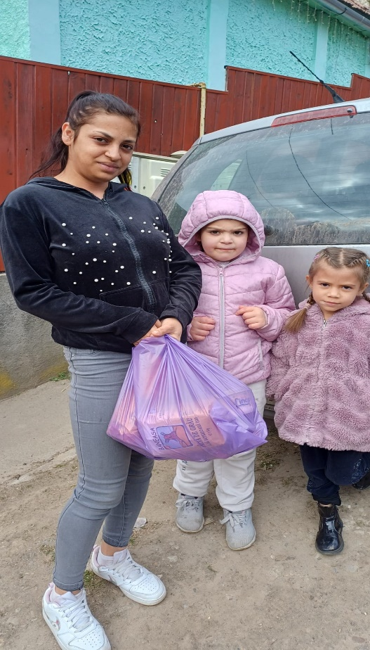

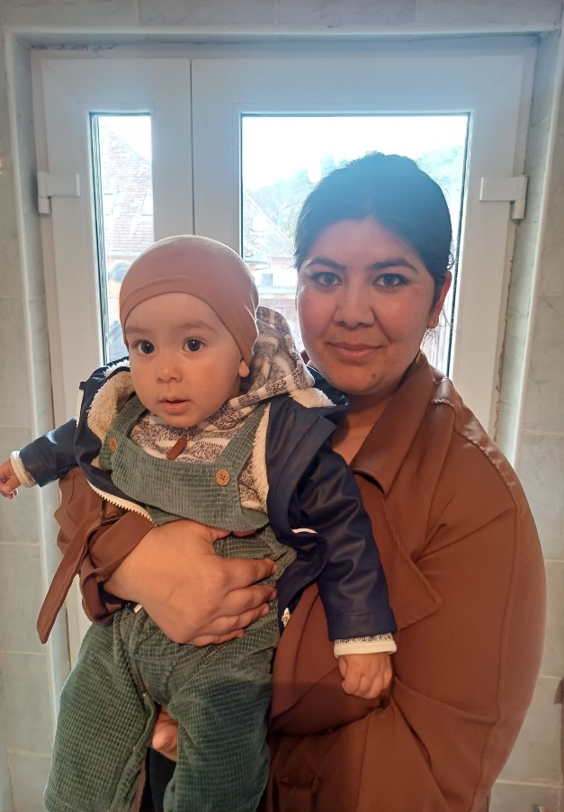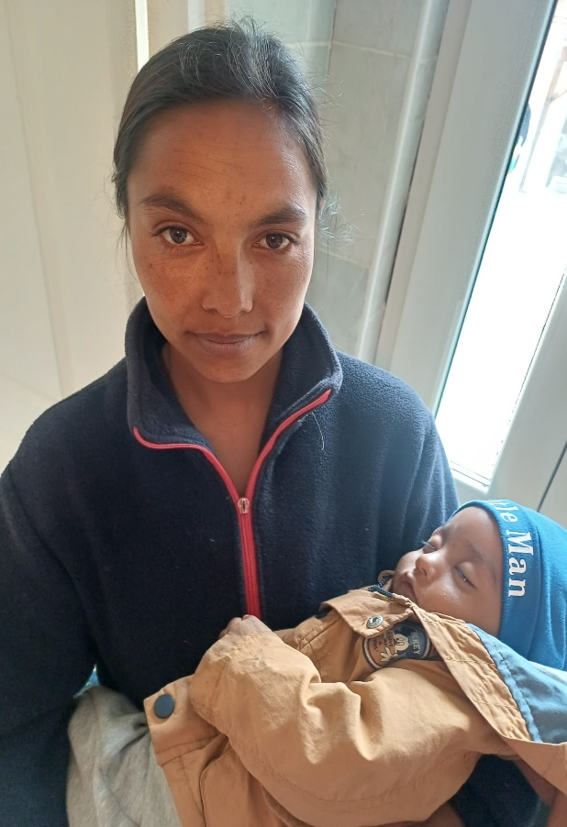

Our center is open every week on Tuesday and Thursday for our clients were we offer free pregnancy test, post abortion counseling, medical aid for babies ( prescription ), spiritual counseling.
Our ministry is continue to serve the poor communities in Sighisoara and to meet their needs as much as we can. Not always we are able to do so but we do our best to come in the help of those who are in great needs.

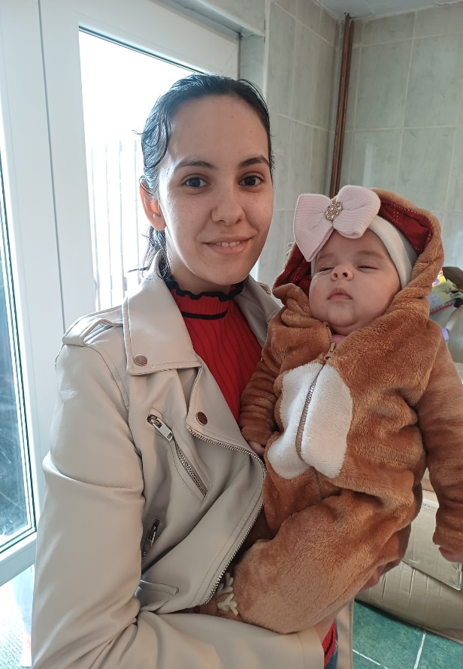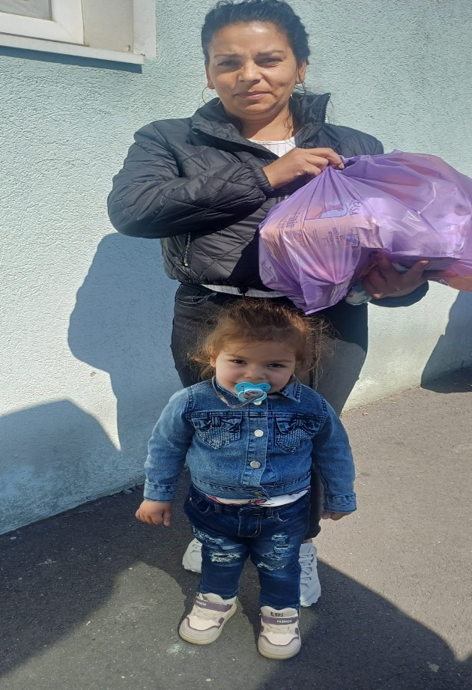

Psalm 127:3 “Behold, children are a gift of the LORD,The fruit of the womb is a reward.”
Children who are cherished, guided, and pointed toward the Lord become a lasting testimony of His grace in a family’s life.

4 YEARS AWAY FROM HOME
Our two refugees ladies from Ukraine became part of our ministry since 1th of May 2022.It is hard to believe that after four years they cannot go back home in Ukraine to live there only for a short visit and to return because is still dangerous in Harkiv. Olha 85 years old today and her daughter Olena 58 years old,they found shelter, protection,food and friendship in our center. Please continue to pray for our two friends , they planned to visit Ukraine next month in June for two weeks.

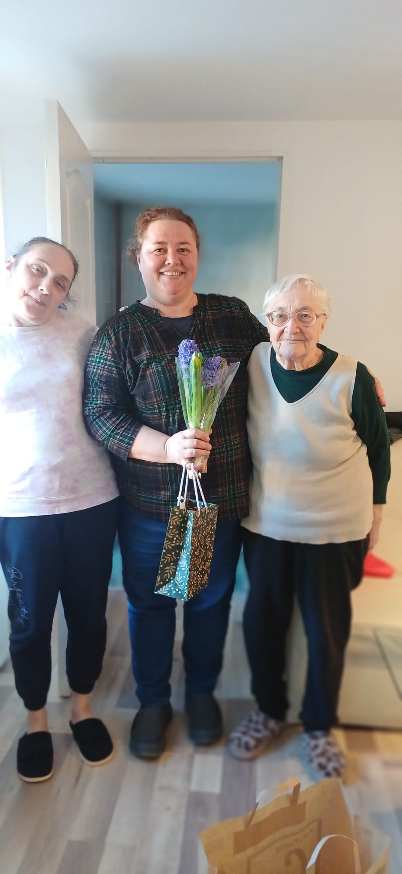

Future events
On May 2026 our new tenance pastor Tavi and Hannah with their little boy Emanuel are going to USA to visit Hannah family for 2 weeks.

On June 2026 Lidia with her husband Virgil will go in Holland to raise support herself to be able to continue to work at Casa Vietii.

From 5th-23th June I am visiting our partners in Huntsville, Alabama USA after nine years of absence. My schedule is still to be determinate but from 10-17th June I will spend time with Tommy and Barbara Glenn in the Smocky Mountains Tennessee.
I intend to reconnect with old and new friends who visit Romania and wants to visit in the future.

Information on giving:
Mihaela Mihai, Director
Email address: casavietiioffice@gmail.com or mihai.mihaela1@gmail.com
Romanian Account Information: Asociatia Casa Vietii Sighisoara C.I.F. 23994635 Tache Ionescu Nr. 10 Sighisoara, Mures 545400
In RON R065BTRL02701205J37136XX
In GBP R015BTRL02707205J37136XX
UK Donations: janet@amentrust.co.uk A.M.E.N. 79 North Road, Dartford Kent
DA1 3ND, United Kingdom For Mihaela Mihai/Casa Vietii in Romania
US Donations Assisting Romanian Ministries 1909 Lynnbrook Drive Huntsville,
AL 35803 Tax-deductible 501(c)3 non-profit armromania@gmail.com For Mihaela Mihai/ Casa Vietii

